Year 7

Term 4 Test

2017

Name: ______________________ Class: ______ Time: 50 minutes Total Mark:____/42

Show working and answers on this sheet. Show working in sufficient detail to support your answers. Incorrect answers without supporting reasoning will be allocated zero marks.

Resources: 1 A4 page of notes (1 side), Calculator allowed, Protractor, Ruler.

Question 1 2 marks

Using a protractor measure the size of the following angles:

- b)


Question 2 4 marks

Identify the type of angle in the following:
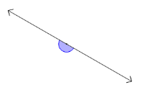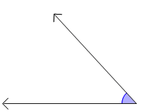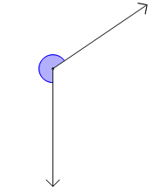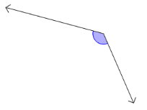

- ______________ b) _______________ c) _______________ d) _________________

Question 4 7 marks

Find the value of the unknown number:
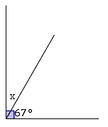
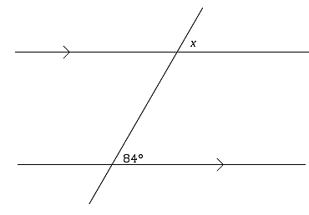
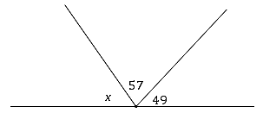
- b) c)

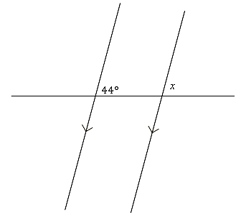
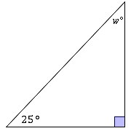
d) e)

Question 5 4 marks

Determine whether the lines AB and CD are parallel. Justify your answer.
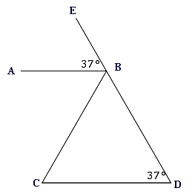
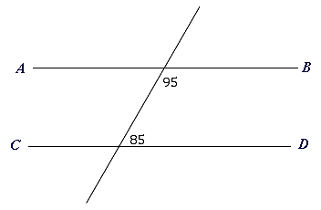
a) b)

___________________________________ ___________________________________

Question 6 4 marks

Write the following as a percentage , Round to 1 decimal place:
- 15 out of 100 b) 2 out of 10

- 4 out 12 b) 27 out of 42

Question 7 4 marks

Calculate 10% of $70: Calculate 45% of $450:

Question 8 3 marks

A mixed netball team has 7 boys and 8 girls:

- Express these numbers as a ratio of boys to girls.

- A new boy joins the team. What is the new ratio in simplified form?

Question 9 5 marks

Solve the equations clearly showing the method used :

- $x+4=15$ b) $\frac{y}{2}=6$ c) $5x+2=17$

Question 10 3 marks

The perfect cheese burger has 2 slices of cheese for every 1 beef patties.
- Write the ratio of cheese slices to beef patties

- If you wanted triple cheese burger (3 beef patties) how much cheese would you need?

- If you made a tower burger using 18 slices of cheese, how many beef patties would you need?

Question 11 4 marks
- Write the following as a rate

- 200m in 20 seconds ii) 270 points in 9 games

- If Ben earns $400 in 2 weeks, how much does he earn in.

- 1 week ii) 5 weeks

Question 12 2 marks

Rewrite the following word equations using symbols:

- When a number is subtracted from nine the answer is seven.

______________________________

- When a number is tripled and then twelve is added the answer is 42.

______________________________

END OF TEST

